**Understanding and Using stepper motor in Projects:**

**Stepper motors** are increasingly taking its position in the world of the electronics. Starting from a normal Surveillance camera to a complicated [CNC machines](https://circuitdigest.com/microcontroller-projects/arduino-cnc-machine-project-code)/Robot these [stepper motors](https://circuitdigest.com/tutorial/what-is-stepper-motor-and-how-it-works) are used everywhere as actuators since they provide accurate controlling. A Stepper Motor is a brushless, synchronous motor which completes a full rotation into a number of steps. In this **Arduino stepper motor tutorial** we will learn about the most commonly available stepper motor **28-BYJ48** and how to interface it with **Arduino** using **ULN2003 stepper motor module**.

### **Stepper Motors:**

Let us take a look at this **28-BYJ48 Stepper motor**.

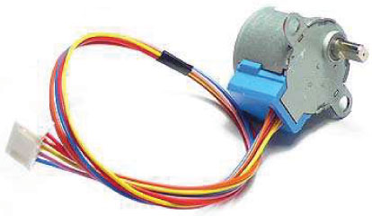

Okay, so unlike a normal DC motor this one has five wires of all fancy colors coming out of it and why is it so? To understand this we should first know how a stepper works and what its specialty is. First of all **steppers motors do not rotate**, they step and so they also known as **step motors**. Meaning, they will move only one step at a time. These motors have a sequence of coils present in them and these coils have to be energized in a particular fashion to make the motor rotate. When each coil is being energized the motor takes a step and a sequence of energization will make the motor take continuous steps, thus making it to rotate. Let us take a look at the coils present inside the motor to know exactly know from where these wires come from.

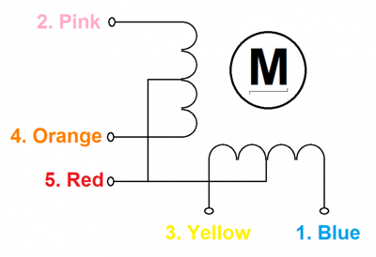

As you can see the motor has Unipolar 5-lead coil arrangement. There are four coils which have to be energized in a particular sequence. The Red wires will be supplied with +5V and the remaining four wires will be pulled to ground for triggering the respective coil. We use a microcontroller like Arduino energize these coils in a particular sequence and make the motor perform the required number of steps.

### **Why so we need Driver modules for Stepper motors?**

Most **stepper motors** will operate only with the help of a driver module. This is because the controller module (In our case Arduino) will not be able to provide enough current from its I/O pins for the motor to operate. So we will use an external module like **ULN2003** module as **stepper motor driver**. There are a many types of driver module and the rating of one will change based on the type of motor used. The primary principle for all driver modules will be to source/sink enough current for the motor to operate.

### **Arduino Stepper Motor Position Control Circuit Diagram and Explanation:**

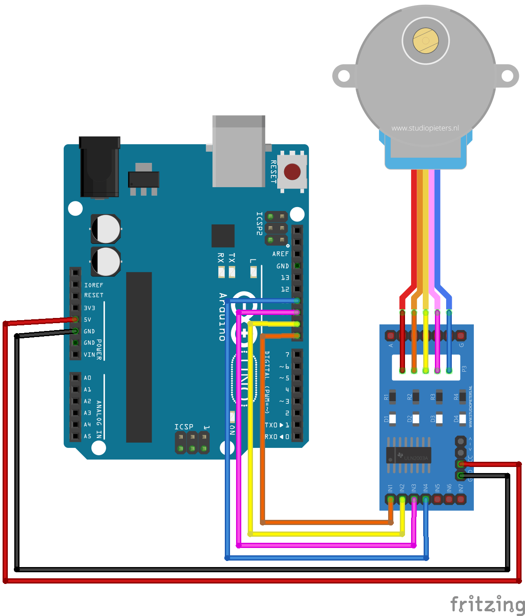

The circuit Diagram for the **arduino stepper motor control project** is shown above. We have used the 28BYJ-48 Stepper motor and the ULN2003 Driver module. To energise the four coils of the stepper motor we are using the digital pins 8,9,10 and 11. The driver module is powered by the 5V pin of the Arduino Board.

But, power the driver with External Power supply when you are connecting some load to the steppe motor. Since I am just using the motor for demonstration purpose I have used the +5V rail of the Arduino Board. Also remember to connect the Ground of the Arduino with the ground of the Diver module.

### **Code for Arduino Board:**

Before we start programming with our Arduino, let us understand what should actually happen inside the program. As said earlier we will be using 4-step sequence method so we will have four steps to perform for making one complete rotation.

| **Step** | **Pin Energized** | **Coils Energized** |
| --- | --- | --- |
| Step 1 | 8 and 9 | A and B |
| Step 2 | 9 and 10 | B and C |
| Step 3 | 10 and 11 | C and D |
| Step 4 | 11 and 8 | D and A |

### **Working of Stepper Motor with Arduino:**

Once the connection is made the hardware should look something like this in the picture below.

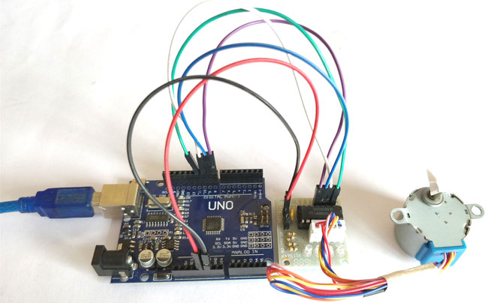

Now, upload the below program in your Arduino UNO and open the serial monitor. As discussed earlier we will have to make 2048 steps to make one complete rotation, so when we enter 2048 the motor will make one complete rotation in clockwise direction by making 2048 steps. To rotate in anti-clockwise just enter the number with “–“negative sign. So, entering -1024 will make the motor to rotate half the way in anti-clock wise direction. You can enter any desired values, like entering 1will make the motor to take only one step.

Hope you understood the project and enjoyed building it. The complete working of the project is shown in the video below. If you have any doubts post them on the comment section below our on our forums.

**Code**

// Arduino stepper motor control code

#include <Stepper.h> // Include the header file

// change this to the number of steps on your motor

#define STEPS 2048

// create an instance of the stepper class using the steps and pins

Stepper stepper(STEPS, 8, 10, 9, 11);

int val = 0;

void setup() {

Serial.begin(9600);

stepper.setSpeed(200);

}

void loop() {

if (Serial.available()>0)

{

val = Serial.parseInt();

stepper.step(val);

Serial.println(val); //for debugging

}

}